**El Espada**

**User Manual**

**Prepared by the Avengers – UIS Force:**

**Avinash Moram**

**Daniel Henderson**

**Zach Parker**

**TABLE OF CONTENTS**

**INTRODUCTION………………………………………………………………………………..3**

**RECOGNITION……………………………………………………………………………....…3**

**NAVIGATION……………………………………………………………………………………4**

**PAGE CONTENT……………………………………………………………………….….......4**

**HOME PAGE……………………………………………………………………………………5**

**ABOUT PAGE…………………………………………………………………………………..7**

**HOURS PAGE…………………………………………………………………………………..8**

**CONTACT US PAGE…………………………………………………………………………..9**

**FULL MENU PAGE…………………………………………………………………………...11**

**START ORDERING…………………………………………………………………………...13**

**ITEM SELECTION...…………………………………………………………………………..14**

**REVIEW ORDER PAGE……………………………………………………………………...15**

**DELETING AN ITEM………………………………………………………………………….16**

**CHECKOUT PAGE……………………………………………………………………………17**

**CONFIRMATION PAGE……………………………………………………………………...19**

**REFERENCES…………………………………………………………………………………20**

**INTRODUCTION**

The purpose of this project is to create a Windows-based software as a standalone application ready to take online orders for a Mexican restaurant. Throughout the development phase the utilization of the latest JDK, Maven, spring boot, H2 database, text files and primefaces to give the program a unique look. The software will give off a unique look by displaying a pictorial menu with prices for each item, a summary page with the listed amounts per item. Easy-to-use payment methods to make the online experience much more user-friendly. The knowledge of successful purchasing and wait time reduction for prompt servicing. We, the UIS Force – Avengers, feel confident that the use of the H2 database should keep the software maintained. Should the database fail, the utilization of text files will suffice.

**RECOGNITION**

Special thanks go to Avinash Moram, Daniel Henderson, and Zachary Parker for making this software in favor of the Mexican community. Special thanks also go Professor Roger West for establishing the workforce towards this endeavor.

**NAVIGATION**

To ensure quality and accuracy of the installation. This manual will navigate you through each page with the use of pictures for better assistance.

**PAGE CONTENT**

The El-Espada website was created to be user-friendly system with little to no complications. The following listed below is the content for the website:

**HOME PAGE**

The home page of El-Espada is the main page for how to order food electronically. The page illustrates 17 menu items. Seven of which are for lunch, six for dinner, and four are dessert. Also, included on the page are the prices for each individual item. Whenever you want to return home just click on “El Espada”.

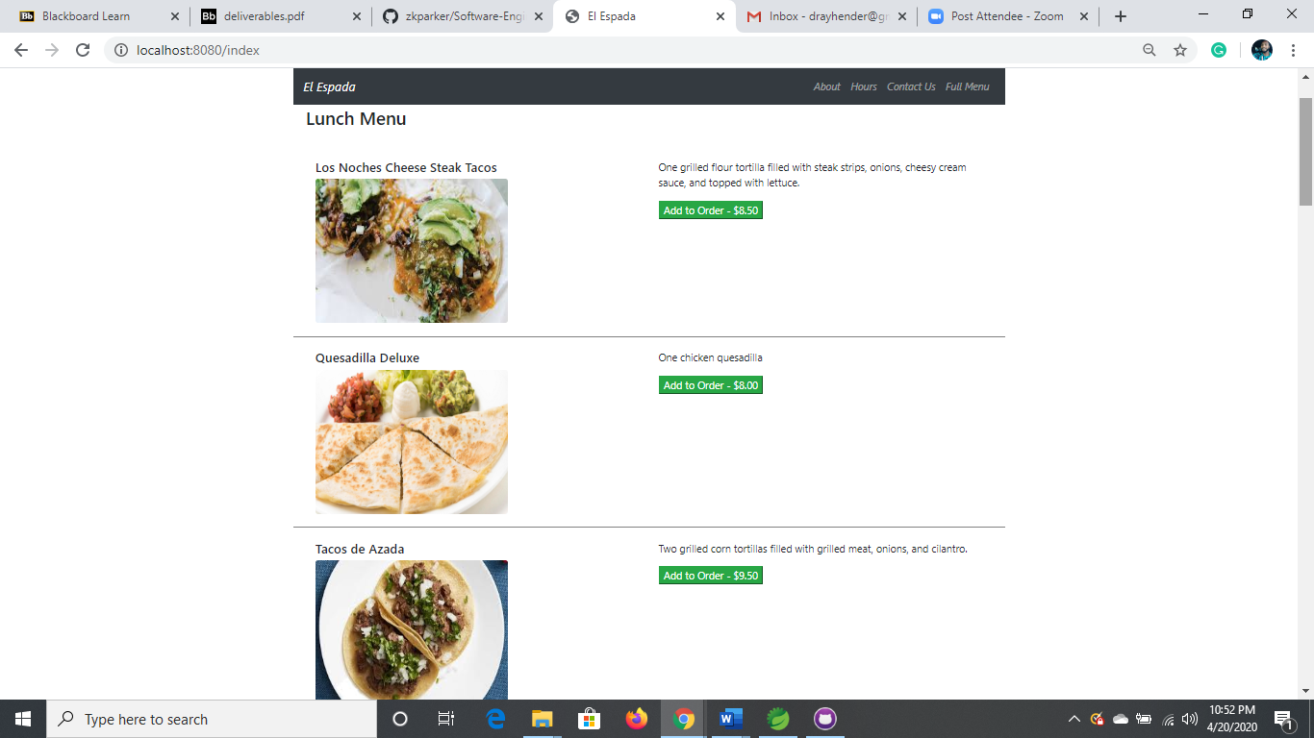

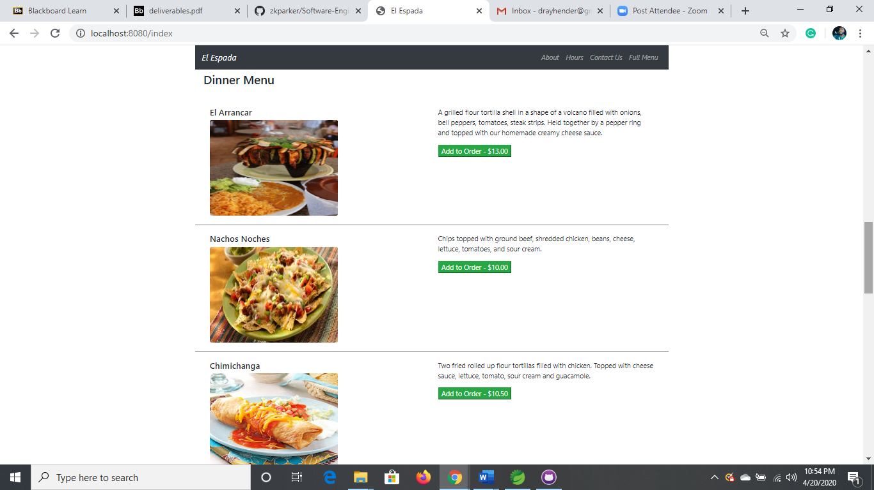

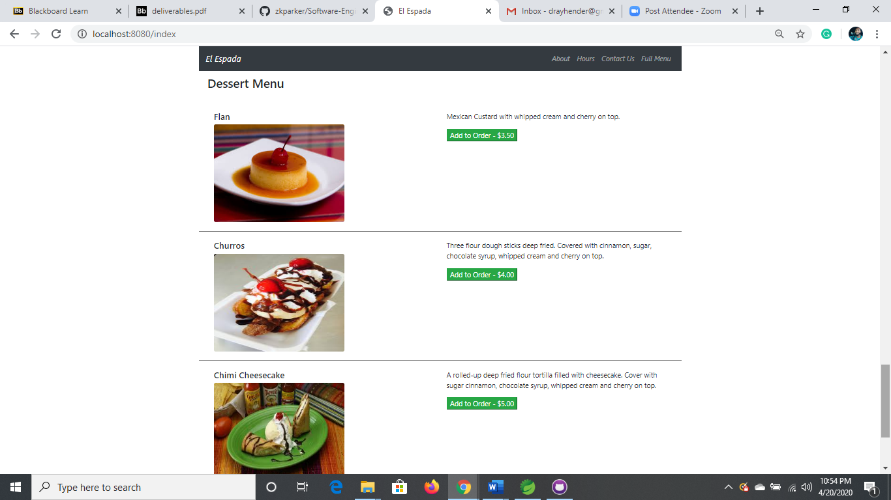

**ABOUT PAGE**

The about page of the site displays information about the idea of the project and the techniques used to help shape its creation. In order to see this information, you must click on “About” at the top of the page.

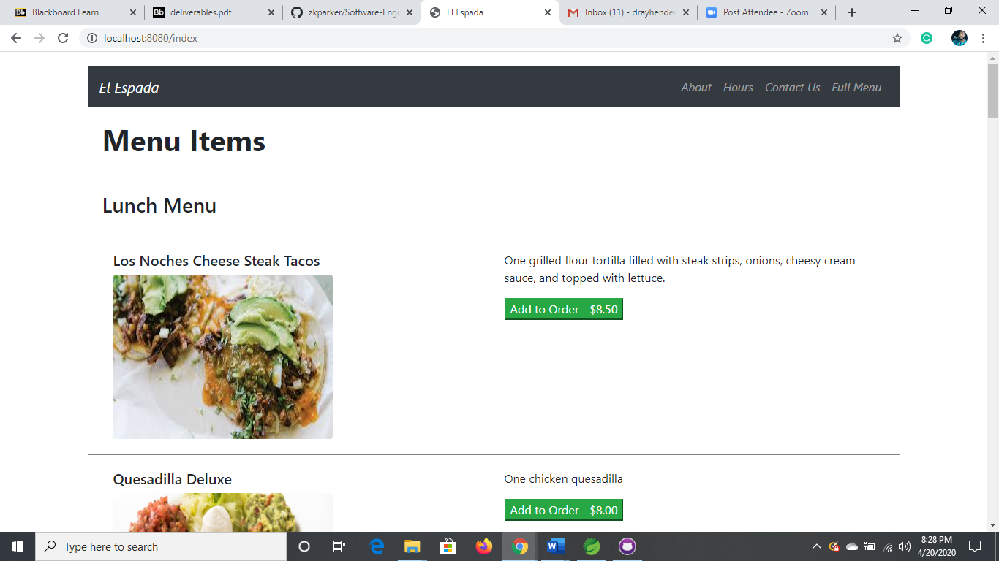

The about page should display.

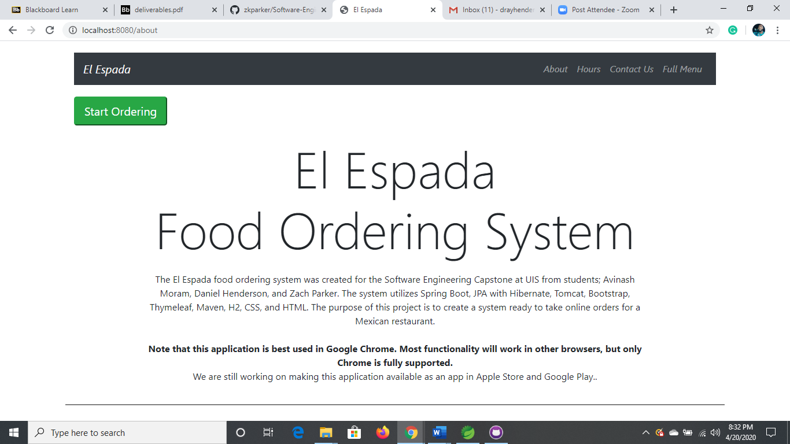

**HOURS PAGE**

The hours page displays the both the times and location of the restaurant. A helpful Google Map is here to assist you with finding your way to our establishment. In order to see the hours in times, you must click on “Hours” at the top of the page.



The hours page should display.

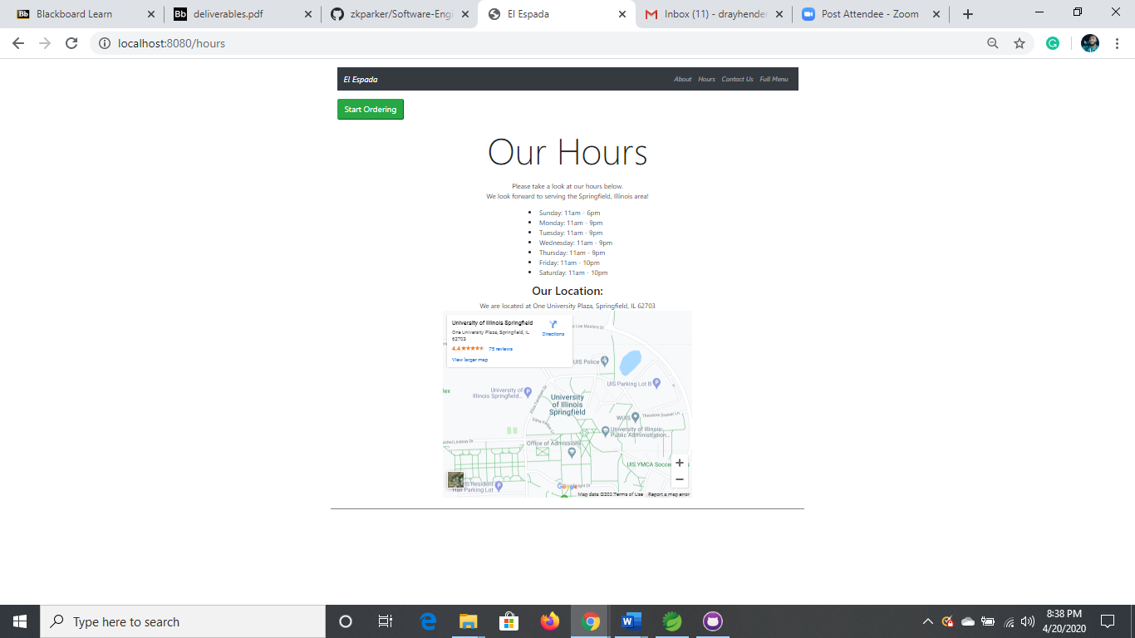

**CONTACT US PAGE**

The contact us page displays information on how to contact the owners of the restaurant. For everyone, the user is prompted to select a method of communication in order to contact the owners. In order to view this page, you must click on “Contact Us” at the top of the page.



The contact us page should display.

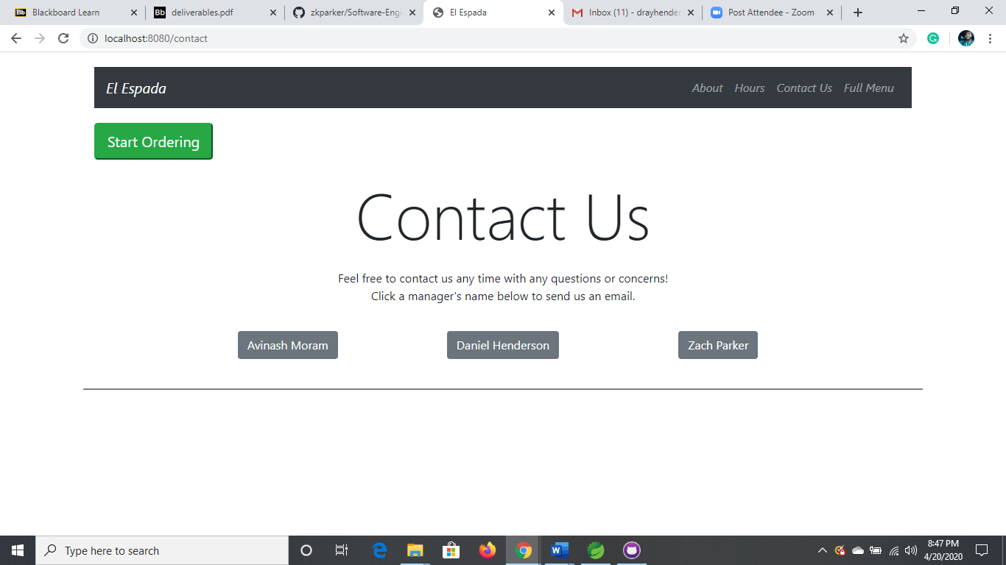

In order to message the owner, you must click on the desired owner and select your method of communication.

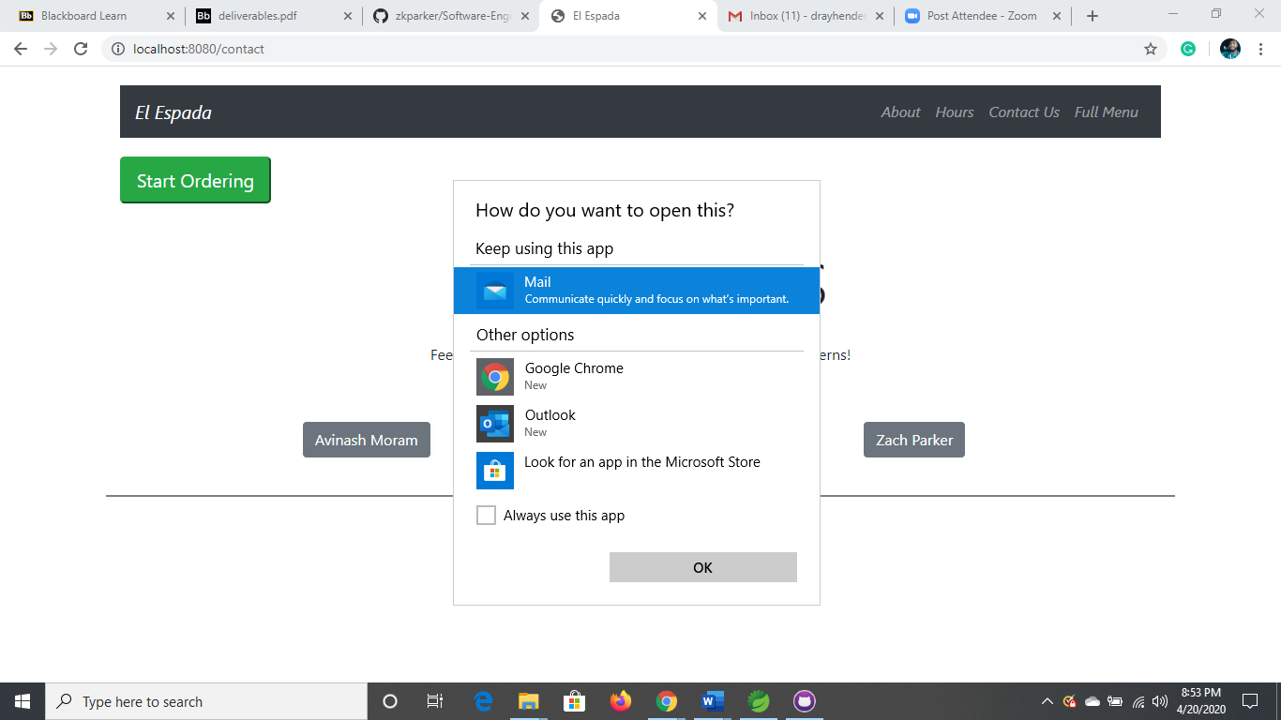

**FULL MENU PAGE**

The full menu page displays the full menu of the restaurant for view to its patrons. In order to view the menu, you must click on “Full Menu” at the top of the page.



The full menu page should display.

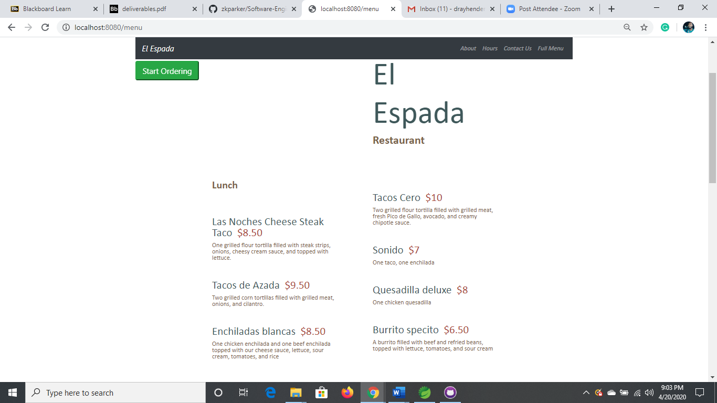

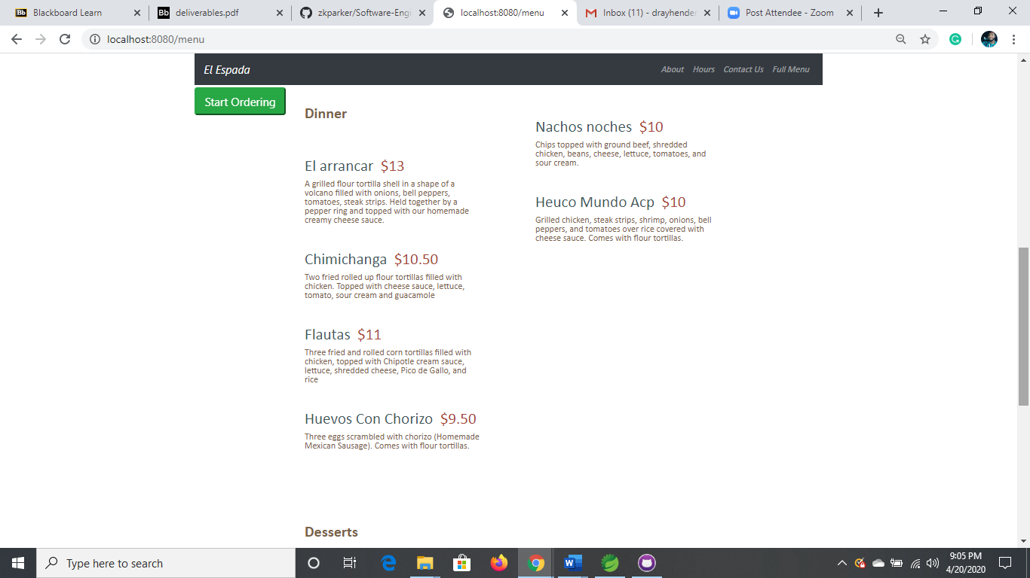

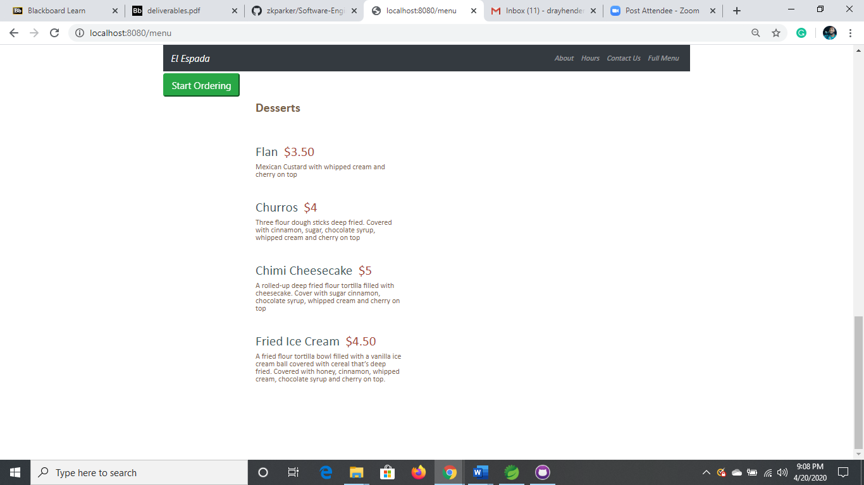

**START ORDERING**

On the about, hours, contact us, and full menu pages is an icon that allows you to start placing your order from any page. Just click on “Start Ordering” at the top of the page to start placing your order.



The home page should display.



**ITEM SELECTION**

When selecting an item, you must click on “Add to Order” when the amount of the price.



You will know the item was successfully accepted when the banner displays.

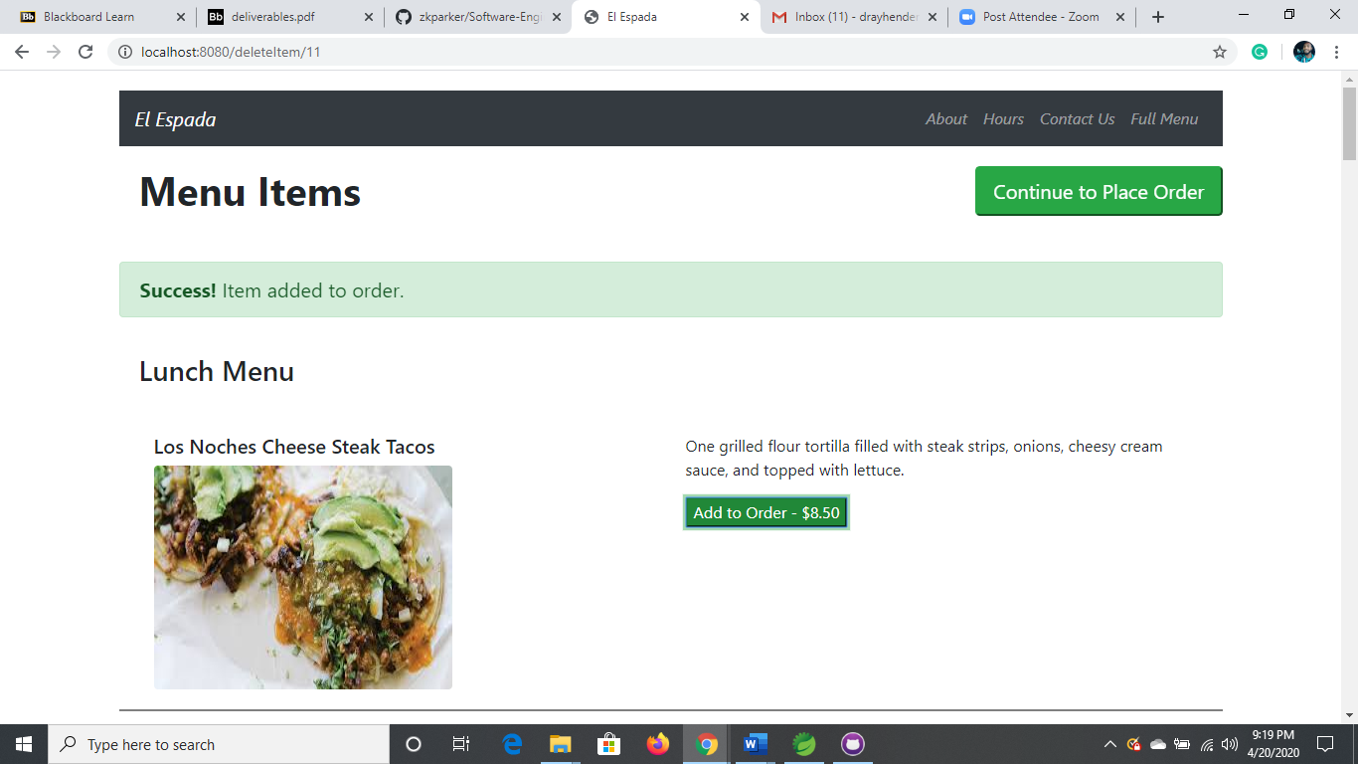

**REVIEW ORDER PAGE**

The review order page displays the selected items from the home page with the amount and order ID number. In order to view this page, click on “Continue to Place Order”.

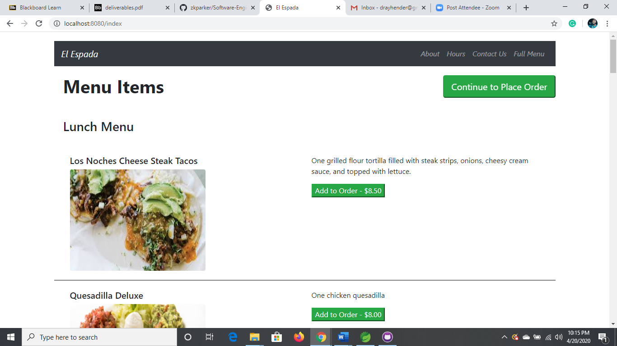

The review order page should display.

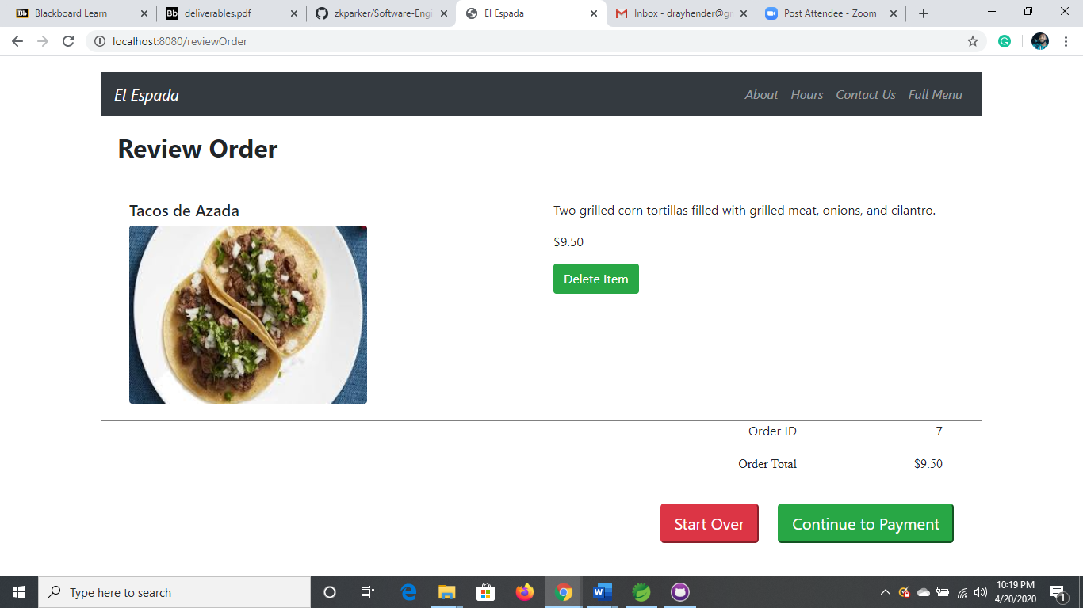

**DELETING AN ITEM**

Made an error; no worries, the site allows for the user to delete an item and start an order over. To delete an item, click on “Delete Item” to remove it from the order.

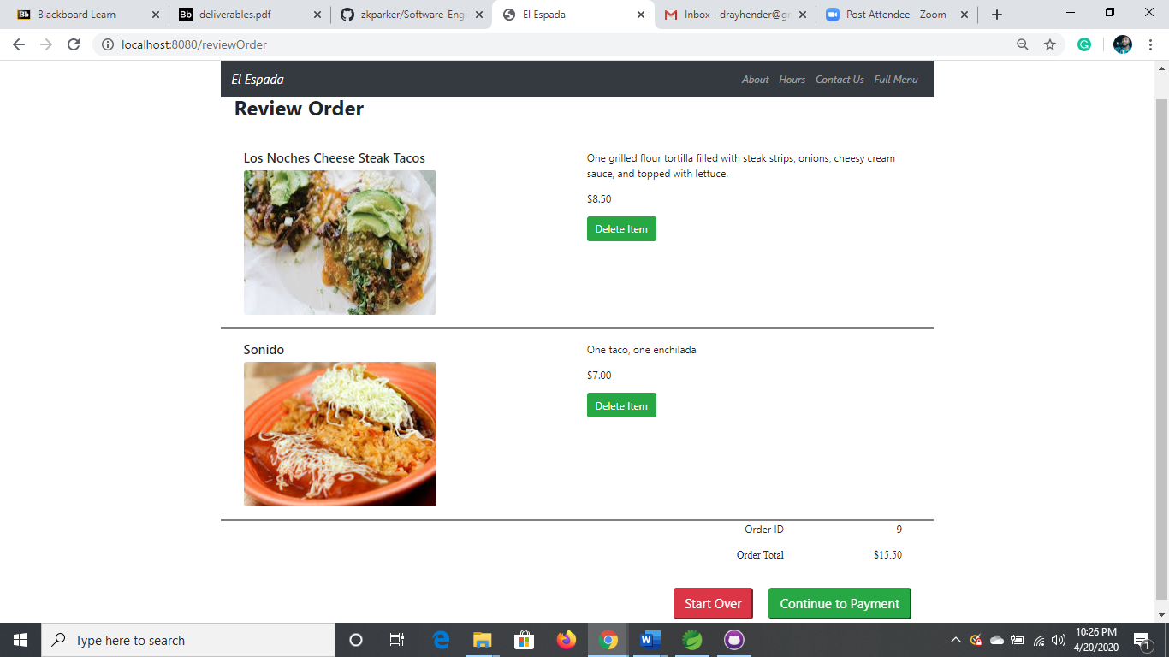

The only the remaining items should be displayed.

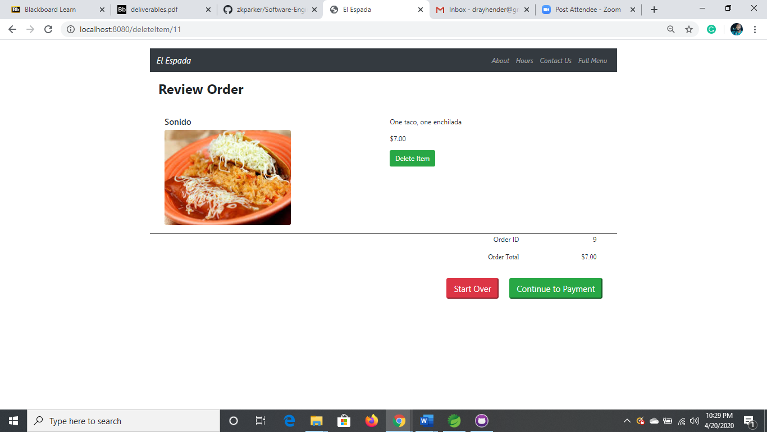

NOTE: Please verify the change in balance as this should be adjusted as well.

**CHECKOUT PAGE**

The checkout page brings you one step closer to placing your first order on the website. The page prompts the user to input their personal information for the complete purchase of the order. In order to view the checkout page, click on “Continue to Payment”.



The checkout page should display.

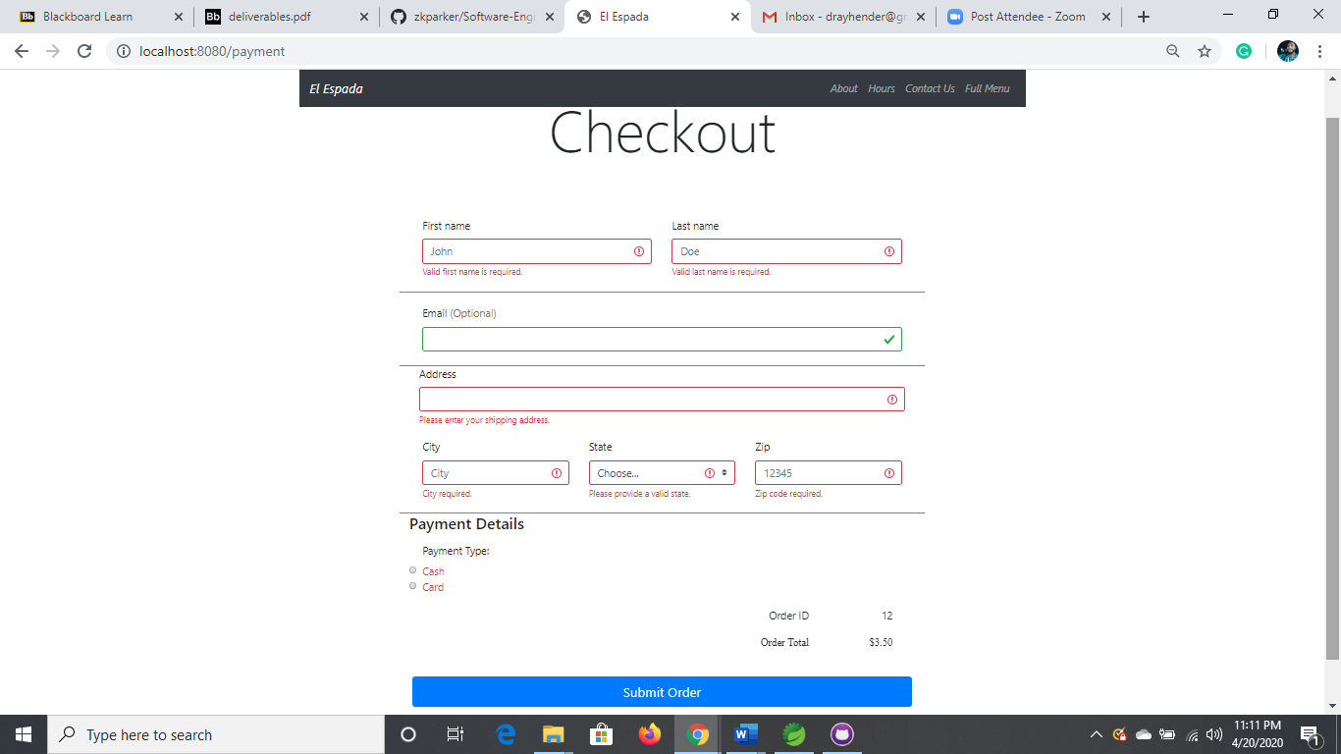

You can elect for only two payment types either cash

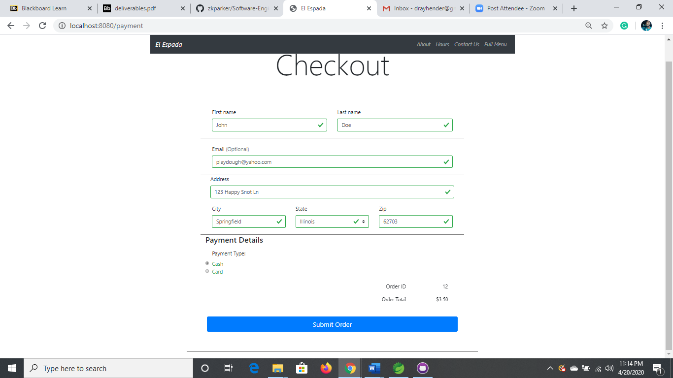

or card.

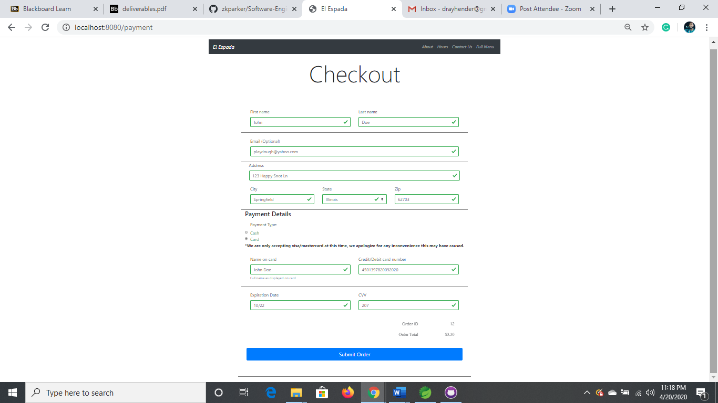

**CONFIRMATION PAGE**

The confirmation page is the final page when it comes to completing your order on the site. The page displays that the payment was successful with an ID number and a time frame for the pickup of the order.

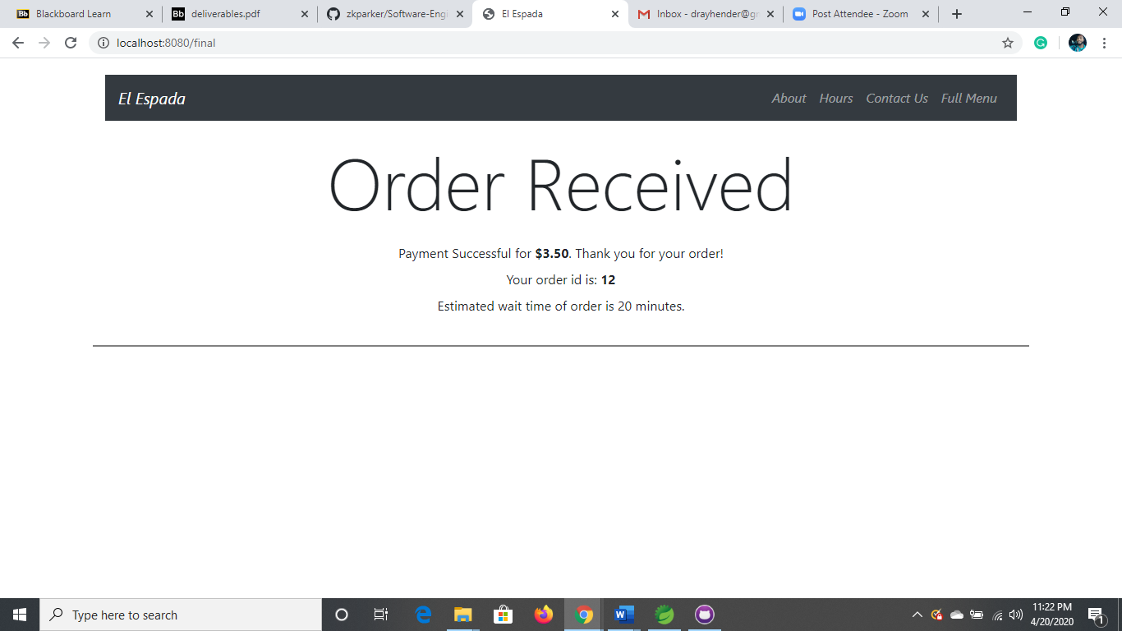

**REFERENCES**

Ariton, G. “*Fancy Something Healthy for Lunch? Try these Yummy Lentil Burritos*” Retrieved from: http://everydaydiabetes.com/food/lunch-eat-lentil-burritos/

Bauer, E. “Chorizo and Eggs” Retrieved from: https://www.simplyrecipes.com/recipes/chorizo_and_eggs/

Cooking Classy (2016) “*Sheet Pan Chicken Fajitas*” Retrieved from: https://www.cookingclassy.com/sheet-pan-chicken-fajitas/

Ezra, G. “*Churros*” Retrieved from: https://www.kosher.com/recipe/churros-recipe-4140

Kenyon, C. (2019) “*Easy Caramel Flan*” Retrieved from: https://www.thespruceeats.com/caramel-flan-individual-servings-2343004

La Tortilleria (2020) “*Tacos de Carne Asada*” Retrieved from: https://latortilleria.com.au/recipes/mexican-recipes/grilled-beef-tacos

Layla (2020) “*Chicken and Avocado Tacos with Creamy Cilantro Sauce*” Retrieved from: https://gimmedelicious.com/chicken-and-avocado-taco/

My Latina Table “Crispy Potato Flautas Recipe” Retrieved from: https://www.mylatinatable.com/crispy-potato-flautas-recipe/

Pinterest (2020) “*Fried Ice Cream Recipe with Cinnamon Sugar Tortilla Bowls*” Retrieved from: https://www.google.com/imgres?imgurl=https://i.pinimg.com/originals/16/23/cc/1623ccf3a3cd74394a284845527e31d1.jpg&imgrefurl=https://www.pinterest.com/pin/38843615513133482/&tbnid=uKjTWxg0snvAvM&vet=1&docid=qv3sK5kTSHqWvM&w=600&h=900&q=fried+ice+cream+bowl&source=sh/x/im

Pinterest (2020) “*Tacos Nayarit, Durango Colorado*” Retrieved from: https://www.pinterest.com/pin/154389093452523686/

Riches, D. (2020) “*Grilled Chicken Quesadilla*” Retrieved from: https://www.thespruceeats.com/grilled-chicken-quesadilla-recipe-334243

Sargento (2020) “*Chili-Cheese Nachos*” Retrieved from: https://www.sargento.com/recipes/mexican/chili-cheese-nachos

Sonido: https://images.app.goo.gl/5FnRkbktrvYxV3XRA

Stoicheff, L. (2018) “*Los Pericos’ Top-of-the-Line Tacos*” Retrieved from: http://goodtimes.sc/restaurants-dining-eating-out-reviews-wine/love-at-first-bite/los-pericos-tacos/

Thompson, S. “*Beef Chimichangas*” Retrieved from: https://www.tasteofhome.com/recipes/beef-chimichangas/

Tres Amigos (2020) “*Photo: Enchiladas Blancas!*” Retrieved from: http://en.tripadvisor.com.hk/LocationPhotoDirectLink-g34352-d7842666-i129447633-Tres_Amigos-Kissimmee_Florida.html

u/nuckiesthebulldbog (2020) “*Chimi Cheesecake*” Retrieved from: https://www.reddit.com/r/FoodPorn/comments/fvomod/chimi_cheesecake/